REPORT

part 2

subpart(a):

The percentage of correctness of testtxt is 67.5% when using cosine similarity function

Input :
output:

subpart(b):
The percentage of correctness of tes.txt is only 40 % when using the negative distance in Euclidean space between the vector. And it scored 67.5% using negative distances in Euclidean space between the normalized versions of the vectors

Input:
Output:

Input:
Output:

subpart(c):

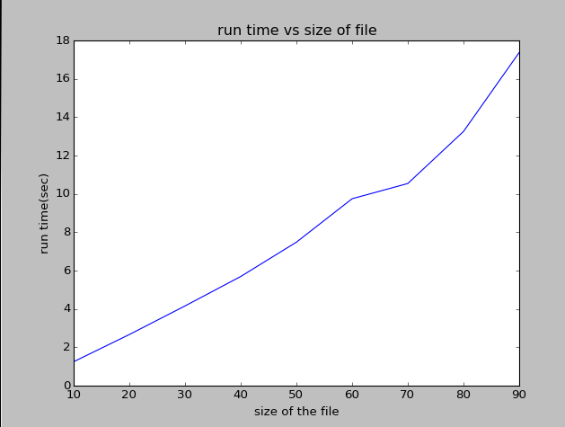

The run time is directly proportional to the size of the file. The larger the file is, the longer the run time.

